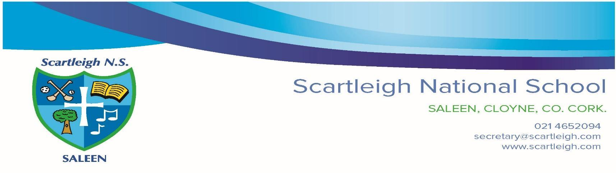
Enrolment 2021/22

We would like to draw your attention to the following Annual Admissions Notice for the 2021/22 school year.
Our Admissions Policy is available here: https://www.scartleigh.com/school-policies

A copy of the enrolment form can be accessed here from the 19th of October, 2020.

Part 1: Admissions to the 2021/22 School Year.
Application and Decision dates for admission to Scartleigh National School 2021/22.
The following are the dates applicable for admission to Junior Infants

1. | The school shall commence accepting applications for admission on | Monday, 19th of October, 2020
2. | The school shall cease accepting applications on | Friday 13th of November, 2020
3. | The date by which applicants will be notified of the decision on their application is | Friday, 4th of December, 2020
4. | The period within which applicants must confirm acceptance of an offer of admission is | Friday, 18th of December, 2020

Note: applications made after the 26-day period will be processed as late applications, the school will consider and issue the decision on late applications in accordance with the school’s admission policy.

Failure of an applicant to accept an offer by Friday 18th of December may result in the offer being withdrawn.

Special Class Applications / Applications to An Cuan and Decision Dates for Admission to 2021/22
The following are the dates applicable for admission to the school’s Special Classes which caters for children with Autism.
Note: The figures set out below in relation to An Cuan are subject to change dependent on whether current students in the Special classes retain their places in the school and whether a student) transfers into the school after the publication of this notice.
1. | The school shall commence accepting applications for admission on | Monday, 4th of January, 2020
2. | The school shall cease accepting applications on | Friday, 5th of February, 2020
3. | The date by which applicants will be notified of the decision on their application is | Friday, 19th of February, 2020
4. | The period within which applicants must confirm acceptance of an offer of admission is | Friday, 5th of March, 2020

Note: applications made after the 26-day period will be processed as late applications, the school will consider and issue the decision on late applications in accordance with the school’s admission policy.
Failure of an applicant to accept an offer by Friday 5th of March may result in the offer being withdrawn.

Other Year Groups Applications and Decision Dates for Admission to Scartleigh National School
The following are the dates applicable for admission to other year groups (Snr Inf to 6th Class)
1. | The school shall commence accepting applications for admission on | Monday, 19th of October, 2020
2. | The school shall cease accepting applications on | Friday 13th of November, 2020
3. | The date by which applicants will be notified of the decision on their application is | Friday, 4th of December, 2020
4. | The period within which applicants must confirm acceptance of an offer of admission is | Friday, 18th of December, 2020

Note: applications made after the 26-day period will be processed as late applications, the school will consider and issue the decision on late applications in accordance with the school’s admission policy.
Failure of an applicant to accept an offer by Friday 18th of December may result in the offer being withdrawn.

Information about the number of places that will be available in the next school year 2021/22
The figures set out below in relation to the Special class are subject to change dependent on whether current students in the Special Classes / An Cuan retain their place in the school and whether a student(s) transfers into the school after the publication of this Notice.
The number of places being made available in Junior Infants is; | 52
The number of places being made available in the Special class/An Cuan for children with ASD is; | 9

The number of places being made available in other year groups is.
Senior Infants | 14
1st Class | 3
2nd Class | 2
3rd Class | 6
4th Class | 0
5th Class | 0
6th Class | 0

Scartleigh National School has accepted applications for places prior to the commencement of Section 62 of the Education (Admissions to Schools) Act 2018 on the 1st of February 2020. The number of those places accepted for 2020/21

Junior Infants | 38
Special Classes / An Cuan | 3
Other Year Groups | 3

Should you wish for us to contact you to inform you of the enrolment window information for the coming academic years we ask that you complete the ‘Expression of Interest’ forms. This is not an application form and does not constitute an application/enrolment process.

